Epiretinal Membrane
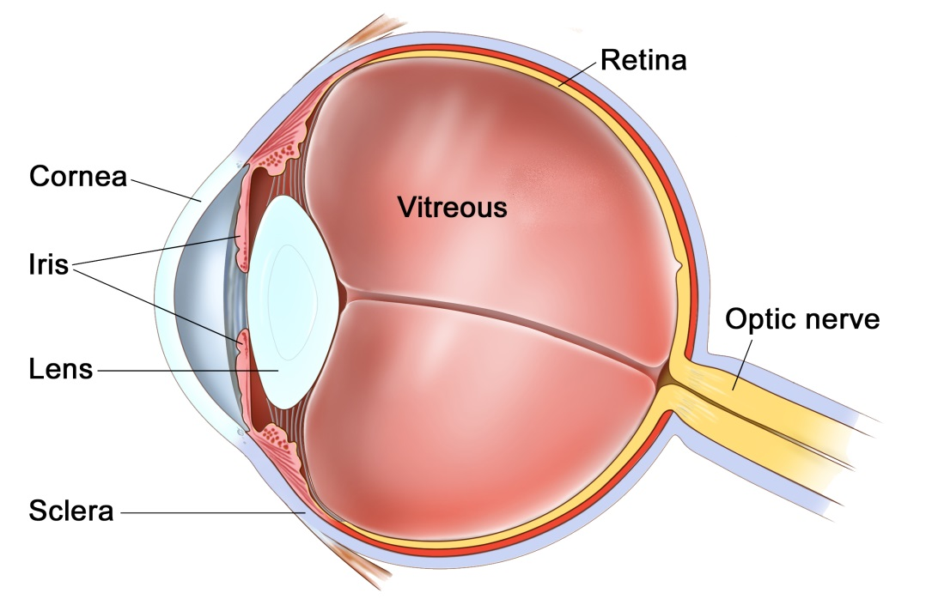
The eye
The eye is like a camera, with a lens at the front to focus light, and a film at the back to capture an image. The photographic film of the eye is known as the retina. In between the lens and the retina, the eye is filled with a gel, known as vitreous.
The vitreous gel was important during development of the eye where it acted as a scaffold for blood vessels. After birth the gel is no longer required and gradually liquefies and shrinks in size. Inevitably, usually after 40 years or more, the gel has shrunk so much that it can no longer completely fill the cavity of the eye. At this point the vitreous gel separates from the retina in a process known as a ‘posterior vitreous detachment’ or ‘PVD’. This is a natural process and occurs in everybody with time.
As with many conditions, this natural process can occasionally go wrong resulting in a range of medical conditions, such as floaters, vitreous haemorrhage, detached retina, epiretinal membrane, or macular hole. These conditions alter the focus of light entering the eye and cause blurred vision.

What is an epiretinal membrane?
An epiretinal membrane is a thin sheet of scar tissue that develops over the surface of the retina. This scar tissue pulls on the retina and causes it to become swollen and wrinkled. A swollen and wrinkled retina makes the vision blurred and distorted. The condition can also be known as ‘cellophane maculopathy’ or ‘macular pucker’.
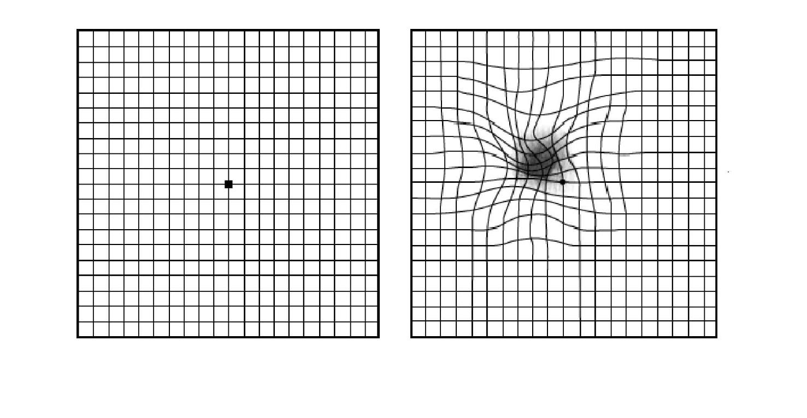
On the left is a grid composed of straight lines known as an Amsler Chart. Patients are asked to look at the central spot on the chart with one eye. On the right is how the chart would look if you had a significant epiretinal membrane. The lines are distorted with blurred patches.

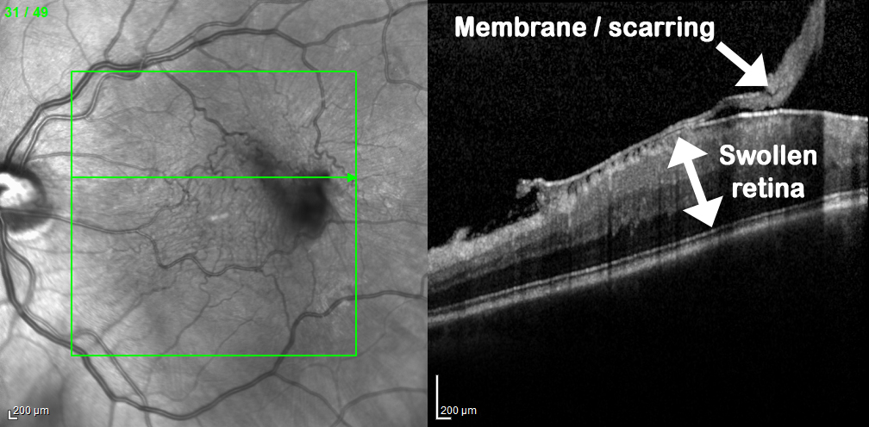
The retinal photograph on the left shows a wrinkled retina. A cross section through this retina shows a thick layer of scar tissue on top of the retina, known as an epiretinal membrane, and a swollen underlying retina with an irregular surface causing distortion.

What causes an epiretinal membrane?
There vast majority of epiretinal membranes are idiopathic, i.e. there is no identifiable cause. It is thought that the epiretinal membrane arises when the vitreous gel is too adherent to the retina. Thus, as the gel shrinks with age, instead of separating from the retina in a process known as a posterior vitreous detachment, it pulls on the retina causing it to become inflamed, creating this layer of scar tissue. In other cases the epiretinal membrane can develop because of blocked retinal veins, retinal tears, uveitis, or other pathology. It is important to rule out other possible causes for the epiretinal membrane when you see your ophthalmologist.

Do I need to remove the epiretinal membrane?
If you are not aware of the epiretinal membrane, and it was detected by chance, then it is advisable to leave it alone. It may stay exactly as it is and never get any worse. Equally, without surgery it will never get any better.
If the epiretinal membrane is causing blurring or distortion, and this is noticeable on a day to day basis, or the epiretinal membrane is becoming progressively worse, then it may be worth removing it with a vitrectomy and epiretinal membrane peel.

What is a vitrectomy?
A vitrectomy is a surgical procedure that removes the vitreous gel from the eye. This allows the epiretinal membrane to be peeled away. The operation is very much like modern day case cataract surgery. It is usually performed whilst you are awake as a day case procedure, although if you would prefer the procedure can be done with sedation or a general anaesthetic. It takes about 30-40 minutes. Three pinpricks less than 0.5mm in diameter are made at the front white part of the eye (sclera) and the gel is removed through these. The eye has a pad for one night, and you have eye drops for 4 weeks afterwards.

Are there any risks?
The main thing to say with epiretinal membrane surgery is that even with surgery vision will never be perfect. The development of the epiretinal membrane would have caused some permanent damage to the vision. The vision can be improved, but it will never be perfect, or as good as the other eye. You will always have some degree of blurring or distortion. Following surgery the vision is often worse for the first couple of weeks, and then gradually improves. Most improvement happens in the first 3-4 months, although the vision will continue to improve beyond one year.
With this in mind, there are also risks related to the surgery. In about 1 in 20 (5%) of people the membrane is very adherent to the retina, and in the process of removing the membrane the retina may be damaged, meaning that you may have slightly more blur and / or distortion afterwards. This would be permanent.
If you have not had cataract surgery, then all patients within 1-2 years of surgery will develop a cataract. Cataracts are a cloudy lens in the eye that blurs the vision and cannot be corrected with glasses. Cataracts are a normal natural part of aging, and most people will require cataract surgery in their lifetime anyway. The lens can be removed at the time of the vitrectomy to prevent it becoming cataractous, or the cataract can be removed separately when it develops.
About 1 in 20 people may require a temporary gas bubble in the eye after surgery. This is of little consequence except it means that you cannot see clearly or fly for about 3 weeks.
About 1 in 100 patients can develop a detached retina, where the lining of the eye peels away. This would require an operation to fix, but can affect the vision if it is not caught early enough.
About 1 in 1000 patients can develop an infection or some bleeding in the lining of the eye. Both of these conditions can blind the eye.

Where can I find more information?
http://www.nei.nih.gov/health/pucker/pucker.asp
http://www.moorfields.nhs.uk/condition/epiretinal-membrane
http://en.wikipedia.org/wiki/Epiretinal_membrane

Important information
After your operation your sight should gradually improve and the eye feel more comfortable. If at any stage during your recovery you feel that the eye is becoming more painful, or the sight worse, then you must call for advice. Do not wait for your appointment.

Useful Telephone Numbers
Mr Steven Harsum’s Private Secretary 0207 112 8246
Ashtead Hospital 01372 221 400
Optegra (Surrey) Eye Hospital 01483 903 004
St Anthony’s Hospital 0208 335 4678

Emergencies:
Monday to Friday - St Helier Eye Casualty: 0208 296 3804
Evening/Weekend - Moorfields at St Georges: 020 8725 2064

