Macular Hole
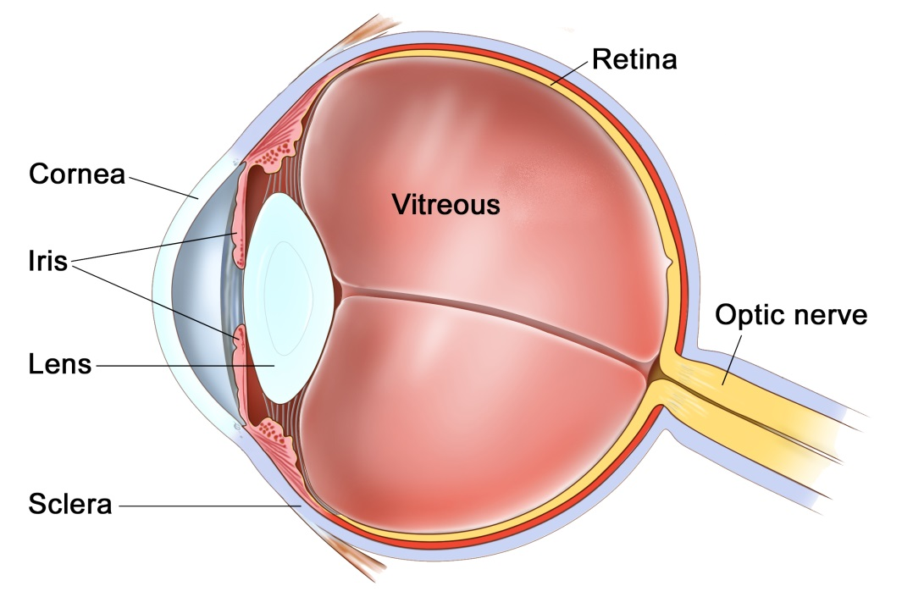
The Eye
The eye is like a camera, with a lens at the front to focus light, and a film at the back to capture an image. The photographic film of the eye is known as the retina. In between the lens and the retina, the eye is filled with a gel, known as vitreous.
The vitreous gel was important during development of the eye where it acted as a scaffold for blood vessels. After birth the gel is no longer required and gradually liquefies and shrinks in size. Inevitably, usually after 40 years or more, the gel has shrunk so much that it can no longer completely fill the cavity of the eye. At this point the vitreous gel separates from the retina in a process known as a ‘posterior vitreous detachment’ or ‘PVD’. This is a natural process and occurs in everybody with time.
As with many conditions, this natural process can occasionally go wrong resulting in a range of medical conditions, such as floaters, vitreous haemorrhage, detached retina, epiretinal membrane, or macular hole. These conditions alter the focus of light entering the eye and cause blurred vision.

What is a macular hole?
The macular is the very centre of the retina, where all light is focused. It is the most important part of the vision and is responsible for fine sharp vision. Damage to the macula causes loss of vision.
A macular hole is a condition where the vitreous gel that fills the eye is too adherent to the retina. As the gel naturally shrinks and pulls away for the retina, during development of a posterior vitreous detachment, it is so adherent to the macular that it causes the macula to rip / tear.
The symptoms of a macular hole are a sudden onset of blurred and distorted central vision. This cannot be corrected with glasses.

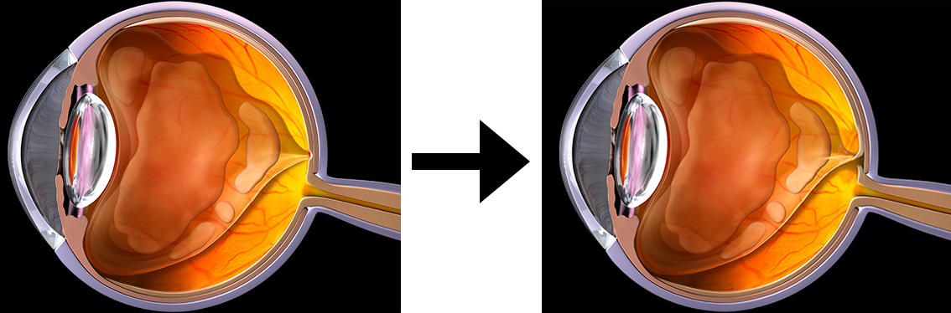
Vitreous separates from the retina and optic nerve but is still attached to the central macula. This may stretch the macula causing macular traction, or rip the macula causing a macular hole.

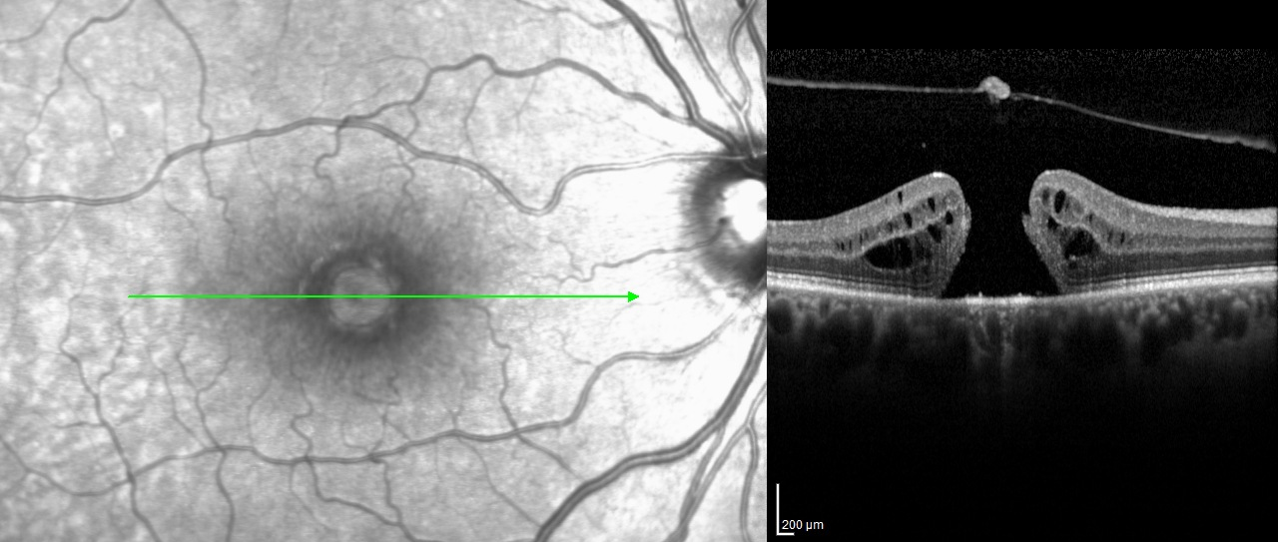
A photograph and corresponding OCT cross-section of a macular hole. In the OCT on the right the vitreous has lifted off from the retina, but has torn a small piece of tissue from the retina, creating a full thickness hole in the retina.

Can a macular hole be repaired?
Once a macular hole has developed the eye sight will never be 100% normal again. If left untreated the central vision will get very slightly worse over the years but you will never lose the peripheral vision.
One danger of not treating a macular hole is that this condition can occur in both eyes! If there are signs of vitreous traction (pulling) on the other macula, then there is a 1 in 8 chance that your other eye may also develop a macular hole. In contrast, if the other eye has had a vitreous detachment, then the risk is less than 1 in 100.
Whilst a vitrectomy and gas procedure can close the hole and improve the vision, the vision will never be normal, and there will always be some degree of blur or distortion that cannot be corrected with glasses.
If the hole has been present for less than a year, the operation will be successful in closing the hole in about 90% of cases. Of these, more than 70% will be able to see two or three lines more down a standard vision chart, compared to before the operation. Even if this degree of improvement does not occur, the vision is at least stabilized and many patients find that they have less distortion.

Does it matter how long I have had the macular hole?
There is evidence that relatively early treatment (within months) gives a better outcome in terms of improvement in vision. Studies have shown, however, that vision improvement may be possible in some patients with long-standing macular holes.

What is a vitrectomy and gas?
A vitrectomy is a surgical procedure that removes the vitreous gel from the eye. This allows access to the macular hole. The operation is very much like modern day case cataract surgery. It is usually performed whilst you are awake as a day case procedure, although if you would prefer the procedure can be done with sedation or a general anaesthetic. It takes about 30-40 minutes. Three pinpricks less than 0.5mm in diameter are made at the front white part of the eye (sclera) and the gel is removed through these. The eye is then filled with a gas bubble. The gas acts as an internal bandage, expanding inside the eye, putting pressure on the hole, and encouraging it to close. This gas bubble last 6-8 weeks. The gas slowly dissolves inside the eye after surgery. After surgery an eye pad will be placed over the eye for one night. Your eye will be checked the next day and the pad removed. When the pad is first removed you will have very poor vision in the eye, worse than before the procedure. This is because the eye is not designed to see through gas. You will be given eye drops to instill 4-6x per day for 4 weeks afterwards. You will be aware within a few days of surgery of a horizontal line at the top of the vision rocking around. This is the bottom of the gas bubble. Day by day it will get lower and lower and begin to round up. By 3 weeks it will be beneath the central vision and your sight will be starting to improve. The gas bubble will take 6-8 weeks to fully dissolve, and you cannot fly in this time. Following surgery most improvement happens in the first 3-4 months, although the vision will continue to improve beyond one year.
The surgery is successful in 85% with one procedure. This means that 15% of patients may require further surgery. In total 95% of holes are eventually closed and 5% are never closed.

Do I have to ‘posture’ after surgery?
In some units, patients are asked to look down to the floor for 50 minutes in every hour for 1-2 weeks. This sort of extreme posturing is only necessary if the hole has not closed after the first attempt.

Are there any risks?
If you have not had cataract surgery, then all patients within 1-2 years of surgery will develop a cataract. Cataracts are a cloudy lens in the eye that blurs the vision and cannot be corrected with glasses. Cataracts are a normal natural part of aging, and most people will require cataract surgery in their lifetime anyway. The lens can be removed at the time of the vitrectomy to prevent it becoming cataractous, or the cataract can be removed separately when it develops.
About 1 in 100 patients can develop a detached retina, where the lining of the eye peels away. This would require an operation to fix, but can affect the vision if it is not caught early enough.
About 1 in 1000 patients can develop an infection or some bleeding in the lining of the eye. Both of these conditions can blind the eye.

Where can I find more information?
www.wikipedia.org/wiki/Macular_hole
www.moorfields.nhs.uk/condition/macular-hole
www.nei.nih.gov/health/macularhole/macularhole.asp

Important information
After your operation your sight should gradually improve and the eye feel more comfortable. If at any stage during your recovery you feel that the eye is becoming more painful, or the sight worse, then you must call for advice. Do not wait for your appointment.

Useful Telephone Numbers
Mr Steven Harsum’s Private Secretary 0207 112 8246
Ashtead Hospital 01372 221 400
Optegra (Surrey) Eye Hospital 01483 903 004
St Anthony’s Hospital 0208 335 4678

Emergencies:
Monday to Friday - St Helier Eye Casualty: 0208 296 3804
Evening/Weekend - Moorfields at St Georges: 020 8725 2064

