Intravitreal Dexamethasone (Ozurdex) Implant

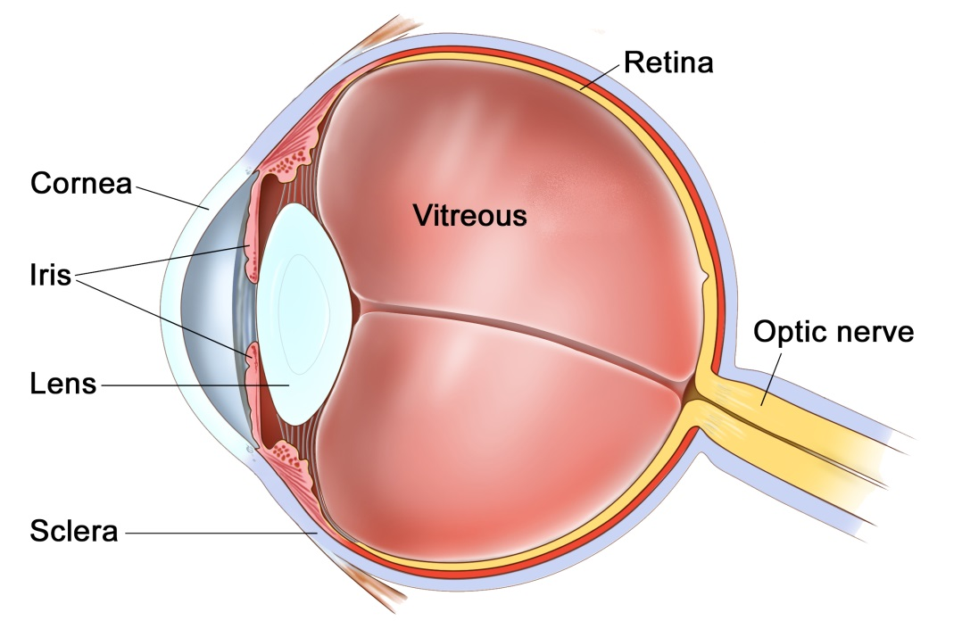
The Eye

Introduction

Your doctor has found that you have leakage of blood vessels causing swelling (oedema) at the back of your eye (the macula). This occurs as a result of different conditions, including diabetes, blockage of the veins at the back of the eye, cataract surgery and inflammation. If left untreated this swelling may result in a permanent reduction in your vision. To try and improve vision, reduce the swelling (oedema), and prevent further deterioration of vision you may be recommended to have a steroid implant injected into the eye. Depending on how the eye responds, these injections may be repeated up to three times per year, or until the oedema has resolved.

The injection (implant)

Ozurdex is an intravitreal implant approved by the National Institute for Health and Clinical Excellence (NICE) for the treatment of macular oedema due to retinal vein occlusion and diabetic macular oedema. The active substance in Ozurdex is dexamethasone. Dexamethasone is a steroid.

This implant is injected into the jelly (vitreous) portion of the eye where it slowly releases steroids over a period of four to six months. During this time the implant dissolves, shrinks, breaks up and usually fully disappears. As the implant dissolves, you should notice the vision improve. After a period of four to six months the vision may either stabilise or deteriorate if the oedema returns.

The implant is the size of a small grain of rice. Immediately after injection you may see it as a large black floater that moves around in the jelly of the eye with time. This usually settles with gravity out of the visual axis and then slowly dissolves. Occasionally the implant can be central and noticeable at times until it has fully dissolved.

Prior to the injection of Ozurdex, your eye has several anaesthetic drops to numb the eye, and the area around the eye is cleaned.

During the injection, which only lasts three to four seconds you should be aware of pushing only and not feel any pain. After your injection you will be given some antibiotic drops to instil four times per day for three to four days.

What are the risks of having the injection?

You need to know about the possible side effects:
- 25-30% of patients may experience an increase in eye pressure as a result of the injection. This is more likely if you have high intra-ocular pressure before the injection or you are a known “steroid responder”. This raised eye pressure is often treated with eye drops and causes no ill effect. However, 1 in 100 may develop permanently raised eye pressure and need lifelong drop treatment or surgery to control the pressure.
- 20% of patients may develop a superficial bleed known as a sub-conjunctival haemorrhage. This is purely cosmetic and usually clears within two weeks and is harmless.
- If you have not had cataract surgery then 4% of patients may develop new cataract or worsening of an existing cataract within 12 months of the injection. Cataracts are harmless but increasingly blur the vision until they are surgically removed.
- Very rarely (1:500) may have an eye infection or a retinal detachment which can blind the eye permanently. This would need urgent surgical repair to minimise damage to the vision.

Other possible limitations

The goal of treatment is to both prevent any further loss of vision and to try and gain vision. However, some of the loss of vision caused by your retinal swelling may be permanent so vision may never fully recover, even with treatment.

Alternatives to the injection

Your doctor will be happy to discuss alternative treatments, although these may not be as effective in controlling your condition, may require more frequent injections or may have a different side-effect profile. Alternatives include laser treatment (which may have already been given), other types of injection called anti-VEGF therapy (Avastin, Lucentis or Eylea), or powdered steroid drug (Triamcinolone).

Post Operatively

You will usually be seen within two to four weeks after your injection and then every two months to ensure your eye is responding well and has no side effects. Please note that follow up consultations are not included in the treatment.

Useful contact numbers:
Mr Harsum’s Private Secretary (020) 7112 8246
Clock House Medical Practice (01372) 840 830
St Anthony’s Hospital (020) 8335 4678

Emergencies:
Monday to Friday St Helier Eye Casualty (020) 8296 3817
Evening/Weekend Moorfields at St Georges Eye Casualty (020) 8725 2064

