Vitrectomy Surgery
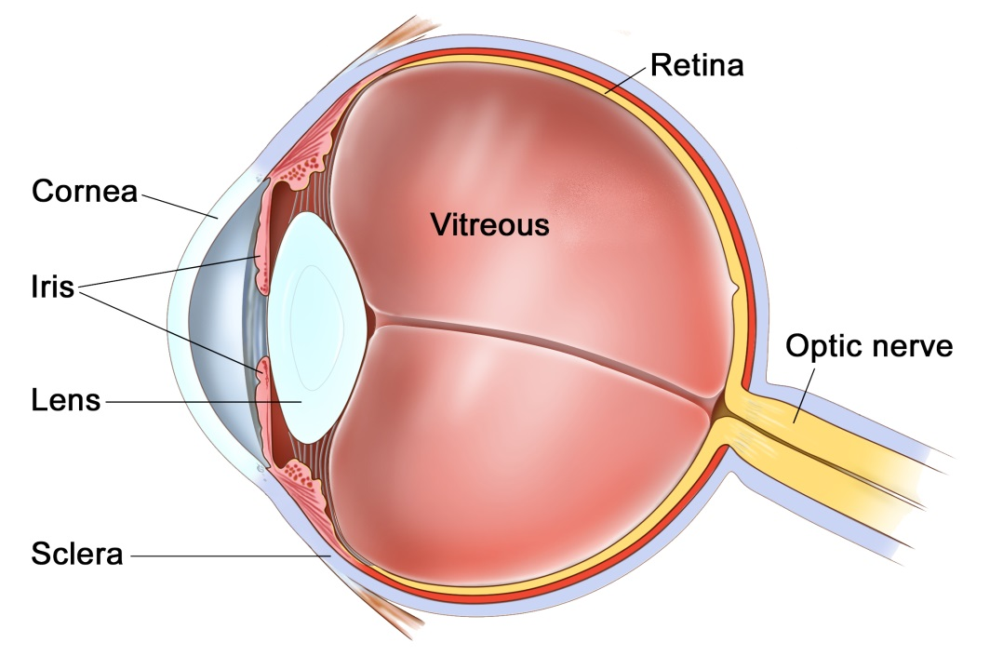
The Eye
The eye is like a camera, with a lens at the front to focus light, and a film at the back to capture an image. The photographic film of the eye is known as the retina. In between the lens and the retina, the eye is filled with a gel, known as vitreous.
The vitreous gel was important during development of the eye where it acted as a scaffold for blood vessels. After birth the gel is no longer required and gradually liquefies and shrinks in size. Inevitably, usually after 40 years or more, the gel has shrunk so much that it can no longer completely fill the cavity of the eye. At this point the vitreous gel separates from the retina in a process known as a ‘posterior vitreous detachment’ or ‘PVD’. This is a natural process and occurs in everybody with time.
As with many conditions, this natural process can occasionally go wrong resulting in a range of medical conditions, such as floaters, vitreous haemorrhage, detached retina, epiretinal membrane, or macular hole. These conditions alter the focus of light entering the eye and cause blurred vision.

What does a vitrectomy involve?
A vitrectomy operation is a surgical procedure that removes the vitreous gel from the eye to clear the vision or to repair the retina. The operation is usually performed as a day case procedure, whilst you are awake, but can also be done in occasional circumstances with you asleep (general anaesthetic).
Prior to your procedure you will be taken to the anaesthetic room where your eye will be numbed with drops followed by an injection. This will numb the sensation, movement, and sight in the eye. You will still have sensation around the eye, but the eyeball itself will be anaesthetised. You will then be taken into the operating theatre where your eye will be cleaned and a sterile drape placed over the eye. This will cover the face, as well as the other eye. It will be lifted off of the nose and mouth, like a tent, with oxygen blowing underneath.
The procedure begins by making three small holes in the white of the eye, known as the ‘sclera’. These holes are so small that they self seal at the end of the procedure, and do not usually require any stiches. Through these holes the vitreous gel is removed. Depending on the reason for the operation there is the possibility that at the end of the procedure, rather than filling the eye with its natural fluid, we may fill it with air, gas, or oil. These fillings are known as ‘tamponades’, and are there to act as an internal bandage, pressing against the retina from the inside.
Depending on which type of operation is being performed the operation typically takes 30 to 90 minutes. At the end of the procedure the eye will have a pad taped over it to hold it closed. This pad can come off the following morning. You may remove it earlier if it is irritating or the eye is no longer being held closed.
If a gas tamponade is used during the operation you will have very little vision until the tamponade has dissolved. As the gas dissolves you will be aware of a reducing ‘bubble’ inside the eye. If air is used this will dissolve within 1 week. If other gasses are used they may last either 3 or 7 weeks. During this time you can not fly.
Oil bubbles do not dissolve and need to be surgically removed a few months after surgery. You can fly with oil bubbles.

The Risks
All procedures carry some degree of risk. Prior to surgery your surgeon will discuss the risks and benefits specifically for your procedure.
If you have not already had cataract surgery, a vitrectomy procedure will speed up the development of age-related cataract. A cataract is a cloudy lens in the eye, that gradually causes blurring of vision, but is otherwise harmless. The cataract can be removed if and when it becomes visually significant.
Other, less common complications of vitrectomy surgery include:
- high or low eye pressure
- retinal detachment
- bleeding inside the eye
- need for additional treatment or surgery
- infection (rare)
- loss of sight

The recovery
After your procedure you will be given a bottle to drops to apply 4 times per day for one month. This drops contains both antibiotic and anti-inflammatory medications.
Typically patients are seen 2 weeks and 2 months post-operatively. Some patients are routinely asked to return the next day, particularly if a tamponade was used.
Post-operatively the eye may feel gritty, but should not be painful. Feel free to take your usual pain-killers at home if you are uncomfortable during the first days.
Please note that three follow-up consultations are included in the procedure for self-funded patients. If you are insured, please check with your Insurer beforehand if any follow up consultations are included in the procedure.

Important information
After you operation your sight should gradually improve and the eye feel more comfortable. If at any stage during your recovery you feel that the eye is becoming more painful, or the sight worse, then you must call for advice. Do not wait for your appointment.
If gas was used for your operation you cannot fly until the gas has dissolved. This may take 1 to 8 weeks, depending on the gas used. You will see the gas bubble shrink and disappear yourself. If you fly with a gas bubble in your eye you will lose your sight permanently.

Telephone Numbers
Post-operative enquires - St Helier Day Case Unit: (020) 8296 3524
Outpatient enquiries - Sutton Retinal Team: (020) 8296 4290
Emergencies:
Monday to Friday - Sutton Eye Casualty: (020) 8296 4368
Evening/Weekend - Moorfields at St Georges: (020) 8725 1794
Frequently asked questions:

- Can I have sedation or a general anaesthetic?
Yes, but this would need to be planned in advance, to ensure that the appropriate staff and a recovery bed is booked.
- What if I am uncomfortable or feel pain during surgery?
During the operation you are able to talk to the surgeon if required, but only do so if it is important. If you are uncomfortable or feel any pain please tell the surgeon. The surgeon can stop to allow you to move or to top up the anaesthetic.
- What if I can’t lie flat?
If you can not lie flat because of breathlessness then please let the team know on the day. We can position you so that your body is reclining, with just the head being flat.
- What can or can’t I do after the operation - Drive, wash hair, shower, sports?
The legal standard for driving is that you can read a car number plate from 20 meters. If you can do this without double vision after your operation then you are legal to drive. Obviously you will need to be more careful than usual until you have recovered your sight fully. You will find it more difficult to judge distance with only one eye.
Washing the face and hair is fine as long as the eye does not have a prolonged soak. Close your eye if you are having a shower. Avoid swimming for 1 month and vigorous sports for 2 weeks.
- How long should I take off work?
Expect your eye to feel gritty and to look bloodshot for the first 1 to 2 weeks. We recommend you take 1 to 2 weeks leave from work. The most important thing is not to rub the eye and to keep the eye clean. As long as you can do this you are fine to do light work, watch TV, and use computers the day after surgery.
- What if I run out of drops?
Your bottle of eye drops is usually enough to last 3-4 weeks. However, if you feel they will not last then you will need to get some more from your GP.

