Panretinal Photocoagulation Laser
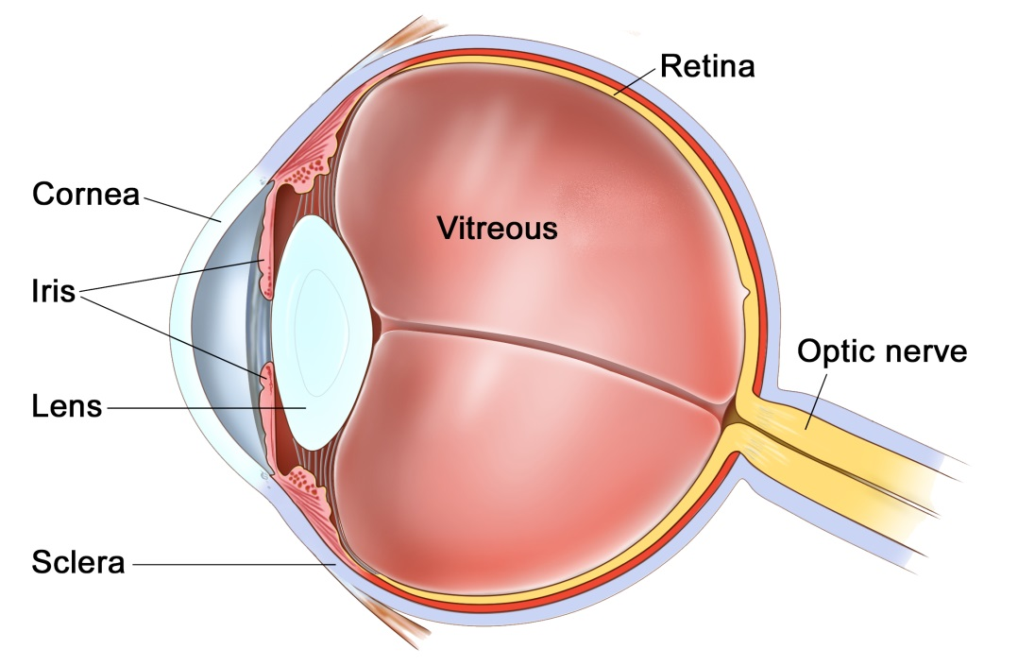The Eye
The eye is like a camera, with a lens at the front to focus light, and a film at the back to capture an image. The photographic film of the eye is known as the retina. In between the lens and the retina, the eye is filled with a clear gel, known as vitreous.
What is Panretinal Photocoagulation?
Panretinal photocoagulation (PRP) is a laser procedure used for conditions where abnormal blood vessels have begun growing inside the eye. These abnormal vessels are harmful to the eye and without PRP laser may cause the eye to become blind and painful.
What conditions are treated with PRP laser?
The commonest conditions that cause abnormal blood vessels to grow at the back of the eye are diabetic retinopathy and retinal vein occlusions. In these conditions the normal retinal blood vessels have been damaged and parts of the retina no longer have a good oxygen supply. A lack of oxygen is known as ischaemia. The abnormal blood vessels that grow in response to ischaemia grow in an out of control fashion, and damage the eye even further.
Will the PRP laser improve my vision?
No. The purpose of PRP laser is to prevent the abnormal vessels from bleeding into the eye and blurring the vision, or to prevent the blood vessels growing into other structures of the eye, leading to blindness. Thus, the aim of PRP laser is to preserve vision and prevent the destructive vessels from causing loss of sight.
What happens during the treatment?
The laser procedure happens as an outpatient procedure. The laser is just like the normal slit lamp that you are examined with in clinic. Prior to the laser you will be asked to sign a consent form listing the risks and benefits of the procedure. After this you will have your eye(s) dilated with drops, as you usually would in clinic. These drops take 15-20 minutes to work and blur your vision for 3-4 hours. You cannot drive for this time. Prior to the laser you will be given anaesthetic drops to numb the surface of the eye. A large contact lens will be placed on the surface of the eye to stop you blinking and to help focus the laser. The laser shots are simply bright flashes of light. You will feel the flashes of light, but they are not painful. The laser treatment often involves firing hundreds of shots in rapid succession to the back of the eye. During one session you may have up to 2000 shots fired. As the procedure continues you may feel an increasing ache behind the eye. The PRP laser procedure may take up to 20 minutes. During this time if you need a break or want to stop simply tell the doctor to stop.
What happens after treatment?
There are no special instructions or drops after treatment. For the first 10 minutes immediately after the procedure your sight will be very blurred and the world will look pink or purple. This rapidly improves and your vision will slowly return to normal as the eye drops wear off. For a couple of days after laser you may have a mild ache.
What are the side effects?
The laser is fired at your peripheral retina. The peripheral retina is used for peripheral vision and night vision. If you have multiple sessions of laser you may notice some loss of peripheral and night vision. If you are a driver and have treatment in both eyes you must inform the DVLA, who will want to perform their own visual field tests. There is a chance you may lose your license.
The laser treatment is performed to reduce the risk of bleeding inside the eye. However, the blood vessels are very fragile and sometimes spontaneously bleed as they are regressing in the days after the laser. Bleeding inside the eye will appear like large black floaters or shadows in the vision. This may take weeks to clear or rarely need an operation to wash out the blood.
Although the peripheral retina is being lasered, the central retina may sometimes become inflamed in response. Inflammation of the central retina can blur the vision and require drops, laser, or injections into the eye to treat.

