Selective Laser Trabeculoplasty (SLT) Laser

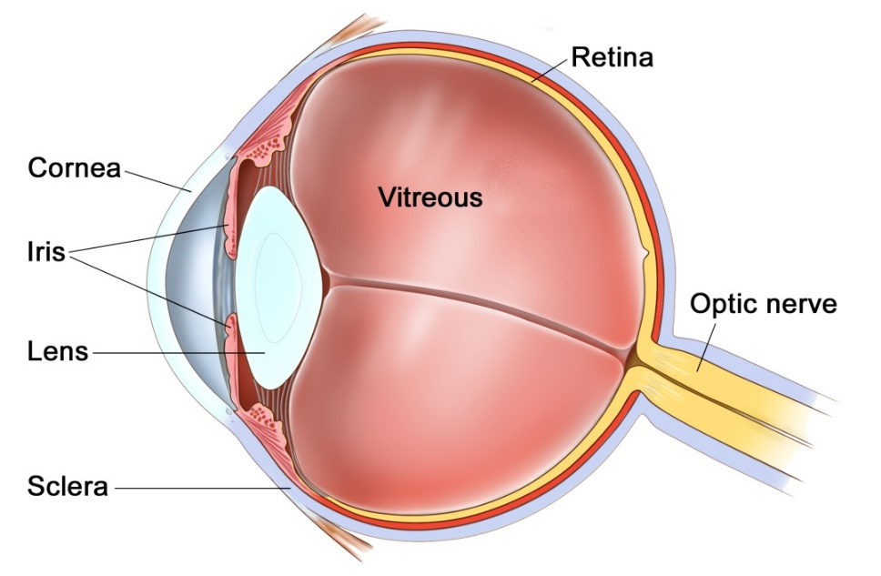
The Eye

The eye is a hollow structure that is filled with clear fluid known as aqueous. This fluid is continually produced by the ciliary body at the back of the eye and is continuously drained away by the trabecular mesh at the front of the eye. If this system becomes unbalanced, and either too much fluid is produced, or there is a blockage of the drainage system, then the eye can become over-inflated, causing the pressure to rise. This is analogous to a football or tyre if too much air is pumped into it. This high pressure can lead to damage of your sight by a condition known as glaucoma. Sight lost caused by glaucoma is permanent and must therefore be prevented.
There are a number of ways this pressure can be lowered. One is to slow the production of fluid with drops or laser, and the second is to increase the outflow of fluid, again with drops or laser. Selective laser trabeculoplasty (SLT) is a type of laser treatment to the drainage system (trabecular mesh) that increases the aqueous drainage and lowers the pressure.
The procedure
The laser procedure is performed in an outpatient setting. When you arrive you will have drops instilled that make the pupil small and to lower the eye pressure. You will then be brought into the laser room where you will be sat in front of a slit lamp microscope that is very similar to the clinic slit lamp microscope used to examine your eyes. A few drops of local anaesthetic will be instilled and a contact lens inserted to stabilise the eye and focus the laser. The procedure is painless and takes approximately 5 minutes per eye. You will be aware of flashes of light only. At the end of the procedure the vision will be blurry for a few hours. Your eye pressure may be checked at the end of the procedure. There are usually no drops or special instructions post-operatively. You can carry out all of your usual daily activities as normal. You will be asked to return to clinic 2-4 weeks later to recheck the eye pressure.

How effective is the procedure?
Selective laser trabeculoplasty is successful in about three out of four patients. If the treatment is successful you may be less dependent on eye drops to control your pressure. The effect of treatment may take several weeks to develop. On average it is possible to lower the intraocular pressure by several mmHg. SLT is not a permanent treatment, and may need to be repeated in the future.

Risks of the procedure
The main risk of the procedure is that it may not work and that your glaucoma may continue to get worse.
The most common side effect is temporary redness and inflammation of the eye which does not usually need treating.
3% of people may have a pressure spike and require medication in the short term to control pressure.

Important information
After your operation your sight should gradually improve and the eye feel more comfortable. If at any stage during your recovery you feel that the eye is becoming more painful, or the sight worse, then you must call for advice. Do not wait for your appointment.

Useful Telephone Numbers
Mr Steven Harsum’s Private Secretary 0207 112 8246
Ashtead Hospital 01372 221 400
Optegra (Surrey) Eye Hospital 01483 903 004
St Anthony’s Hospital 0208 337 6691

Emergencies:
Monday to Friday - St Helier Eye Casualty: 0208 296 3817
Evening/Weekend - Moorfields at St Georges: 020 8725 2064

