Vitreous Haemorrhage
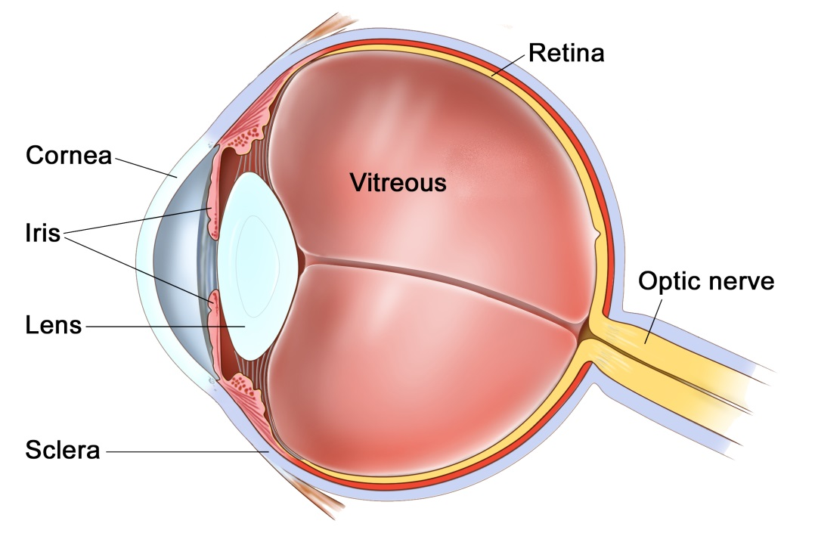
The Eye
The eye is like a camera, with a lens at the front to focus light, and a film at the back to capture an image. The photographic film of the eye is known as the retina. In between the lens and the retina, the eye is filled with a gel, known as vitreous.
The vitreous gel was important during development of the eye where it acted as a scaffold for blood vessels. After birth the gel is no longer required and gradually liquefies and shrinks in size. Inevitably, usually after 40 years or more, the gel has shrunk so much that it can no longer completely fill the cavity of the eye. At this point the vitreous gel separates from the retina in a process known as a ‘posterior vitreous detachment’ or ‘PVD’. This is a natural process and occurs in everybody with time.
As with many conditions, this natural process can occasionally go wrong resulting in a range of medical conditions, such as floaters, vitreous haemorrhage, detached retina, epiretinal membrane, or macular hole. These conditions alter the focus of light entering the eye and cause blurred vision.

What is a vitreous haemorrhage?
A vitreous haemorrhage is bleeding into the vitreous gel of the eye. The bleeding can come from a number of conditions:
Wet macular degeneration – a condition where blood vessels grow beneath the retina. These blood vessels are abnormal and fragile and easily bleed. The blood can break through the retina and fill the vitreous cavity.
Vein occlusion – blood enters the eye through retinal arteries and drains out of the eye through retinal veins. If a retinal vein becomes blocked then the back pressure can cause the capillaries to bleed and leak into the vitreous gel.
Posterior vitreous detachment – As we age the vitreous shrinks and pulls away from the retina. When this happens it can tear or avulse a retinal blood vessel.
Retinal tear or detachment – When the vitreous separates from the retina, if it is too firmly attached to the retina, it can tear the retina, causing bleeding into the vitreous. This is particularly common in short-sighted people or after trauma.
Macroaneurysm – Arteries can sometimes enlarge rapidly in size due to wear and tear or high blood pressure. As the artery enlarges its arterial wall becomes thinner and thinner. Eventually the artery can burst and bleed into the retina, under the retina, or into the vitreous.
Uveitis – In inflamed eyes (uveitis) abnormal blood vessels can grow into the vitreous gel of the eye. As the gel moves these blood vessels may rupture, filling the eye with blood.
Diabetes – Diabetes causes retinopathy. When retinopathy is very severe blood vessels grow from the retina into the vitreous gel of the eye. As the gel moves and pulls on the blood vessels the vessels may bleed into the vitreous.

What are the symptoms of a vitreous haemorrhage?
When bleeding occurs into the vitreous the normally transparent vitreous gel of the eye fills with non-transparent blood. Initially this may be seen as a shower of dense floaters. These floaters gradually disperse and become denser. As this occurs the vision becomes more and more blurred until there is very little sight left.

Do I need to have surgery?
If you have a small amount of blood in the vitreous your ophthalmologist may be able to identify the cause of the haemorrhage. If the cause is known then appropriate treatment can be implemented. In some cases, if the haemorrhage is dense, the ophthalmologist will be unable to see the retina, or the cause of the bleeding. If this is the case then there is a chance that the haemorrhage is due to a tear in the retina or a retinal detachment. This is potentially dangerous. Without urgent treatment the entire retina may detach and blind the eye permanently. Thus, if the retina cannot be examined, then the vitreous haemorrhage needs to be washed out urgently to identify and treat the underlying cause.

How is the haemorrhage removed?
A vitreous haemorrhage is removed with an operation known as a ‘vitrectomy’. This is where the vitreous gel of the eye is removed through three tiny pinpricks in the white of the eye (sclera). The operation is usually performed as a day case procedure, whilst you are awake, but can also be done in occasional circumstances with you asleep if you prefer (general anaesthetic).
If the retina has a tear or has begun to detach, the tear and detachment will be fixed by laser or cryotherapy, and a gas tamponade will be inserted at the end of the operation. The tamponade acts like an internal bandage that expands inside the eye holding the retinal flat against the wall of the eye. This tamponade can last any time between 1 and 3 weeks. Whilst you have a gas tamponade inside the eye the eye will have very little sight. As the gas dissolves you will be aware of a meniscus, a horizontal line, coming down inside the eye day by day.

Are there any risks?
All operations carry some risk, however, without surgery the eye may become blind from a retinal detachment. Compared to blindness the risks are relatively insignificant. One in 1000 can be blinded by infection or haemorrhage within the wall of the eye, 15% will redetach and need further surgery. Some people can have raised pressure or glaucoma which may be permanent.
If you have not had cataract surgery, then all patients within 1-2 years of surgery will develop a cataract. Cataracts are a cloudy lens in the eye that blurs the vision and cannot be corrected with glasses. Cataracts are a normal natural part of aging, and most people will require cataract surgery in their lifetime anyway. The cataract can be removed if and when it becomes visually significant.

The recovery
Immediately after your procedure we may ask you to posture on one side or another, or face down to the floor for a couple of hours. Subsequently, you may have some instructions on which side to sleep on at night for 1-2 weeks.
When you go home after your procedure you will be given a bottle to drops to apply 4 times per day for 4 weeks. This drops contains both antibiotic and anti-inflammatory medications. Typically patients are seen at 1 day, 2 weeks and 2 months post-operatively.
You will not be able to fly if you have a gas tamponade in the eye until the tamponade has dissolved. If you have a general anaesthetic with a gas tamponade you must tell your anaesthetist that you have gas in the eye. Flying and anaesthetics are not a problem if you have a silicone oil tamponade.
We generally advise you to have 1-2 weeks off of work and not to swim for 2 weeks.

Where can I find more information?
http://en.wikipedia.org/wiki/Vitreous_hemorrhage

Important information
After your operation your sight should gradually improve and the eye feel more comfortable. If at any stage during your recovery you feel that the eye is becoming more painful, or the sight worse, then you must call for advice. Do not wait for your appointment.

Useful Telephone Numbers
Mr Steven Harsum’s Private Secretary 0207 112 8246
Ashtead Hospital 01372 221 400
Optegra (Surrey) Eye Hospital 01483 903 004
St Anthony’s Hospital 0208 337 6691

Emergencies:
Monday to Friday - St Helier Eye Casualty: 0208 296 3817
Evening/Weekend - Moorfields at St Georges: 020 8725 2064

