YAG LASER CAPSULOTOMY

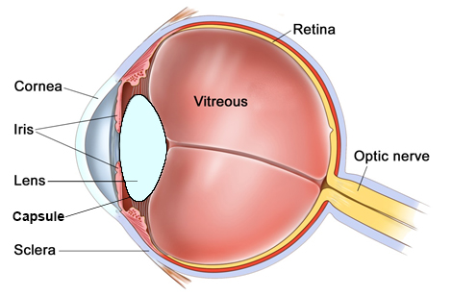
Overview
Just as you have a lens in glasses to focus, there is also a lens inside the eye to focus. This lens is held in position by a thin capsule. When the lens becomes cloudy it is known as a cataract. At the time of cataract surgery a hole is made in the front of the capsule in order to remove the cataract. The remainder of the capsular bag is left behind to help hold the new lens in the correct position.

In approximately 10% of people, after cataract surgery, the remaining posterior part of the capsule can also become cloudy. This blurs the vision, just like the original cataract did, and cannot be corrected with glasses. Some people describe this blurring as being like the original cataract returning. This is not the case, it is simply the capsule that is left behind after surgery, becoming cloudy after time.

Fortunately, this posterior capsular opacity (PCO) can be treated in clinic with laser, and does not require surgery.

What does laser treatment involve?
Laser treatment is performed by Mr Harsum in the outpatient department. You will have drops to dilate the pupil. These take 15 minutes to work. You will subsequently not be able to drive for 3-4 hours, until the drops wear off. You will then be brought into the laser room where you will have some anaesthetic eye drops instilled to numb the eye. These last 30 minutes. The laser is done whilst you are sitting upright, just like a normal examination in the eye clinic. A special contact lens will be placed onto the eye to focus the capsule. As the laser proceeds you will see a flashing light. This is completely painless. The procedure takes up to 10 minutes. Your only instruction will be to look straight ahead. At the end of the procedure the vision may be a bit blurred, and you may be aware of floaters (seeing objects in the field of vision), but by the next day your vision should be better than before surgery. There are no special instructions post-operatively. You can do sports, including swimming as normal. Often a follow up appointment is not necessary, but on occasions we ask some patients to return to the department for further visit.

What are the risks of YAG Laser Treatment?
The risks of laser treatment is incredibly small. However, all procedures carry some risk. There is a risk of some inflammation or bruising of the eye. This is usually minor, but may cause the eye to be red, with blurred vision and photophobia (bright lights hurt the eye). Occasionally the laser beam can mark the lens implant. This can rarely cause glare or cause the lens to move position. Rarely the retina can swell (macular oedema) which can blur the vision temporarily. This may require treatment with eye drops. Again rarely, you can develop a detached retina. This would need urgent surgical repair. The signs of this would be many new floaters in the eye, or a large shadow growing, like a curtain being drawn.

If you have any of these problems then please contact Mr Harsum urgently or see an ophthalmologist for advice. Remember they are all very unlikely to occur.

Useful contact numbers:
Mr Harsum (020) 7112 8246
Monday to Friday Sutton Eye Casualty (020) 8296 4368
Evening/Weekend Moorfields at St Georges (020) 8725 1794

